

**American International University- Bangladesh**

**CSC 2209: Object Oriented Programming 1 (JAVA)**

**CO1 Evaluation**

**Project Summary Report**

**Fall 19-20**

**Group ID: C04**

**Project Title: Library Management System**

|  |  |
| --- | --- |
| Student Name | Student Id |
| Rabbi AKM KAWSER | **15-28286-1** |
| Towsif Refat | **18-36245-1** |
| Shahrukh md Shahriar | **15-30298-2** |
| Debobrata Chakraborty | **18-36103-1** |

**Introduction:**

We tried to create a software which ensures some prime qualities of a library system. Many libraries are still using notebooks to keep their records. But by the time going the world is getting faster. So we created a software which will help a library to keep their records easily.

**User Category:**

There are two types of Users here. They are:

* Admin
* Student

**Feature List:**

In this project the “**Admin**” has the following features:

* View Books
* View Students
* Issue book
* Add Student
* Add Book

In this project the “Student” has the following features:

* View Books
* Return Book
* View issued book

**Frame Description:**

|  |
| --- |
|  |
|  |
|  |
|  |
|  |

**Database Table Description:**

|  |
| --- |
|  |
|  |
|  |
|  |

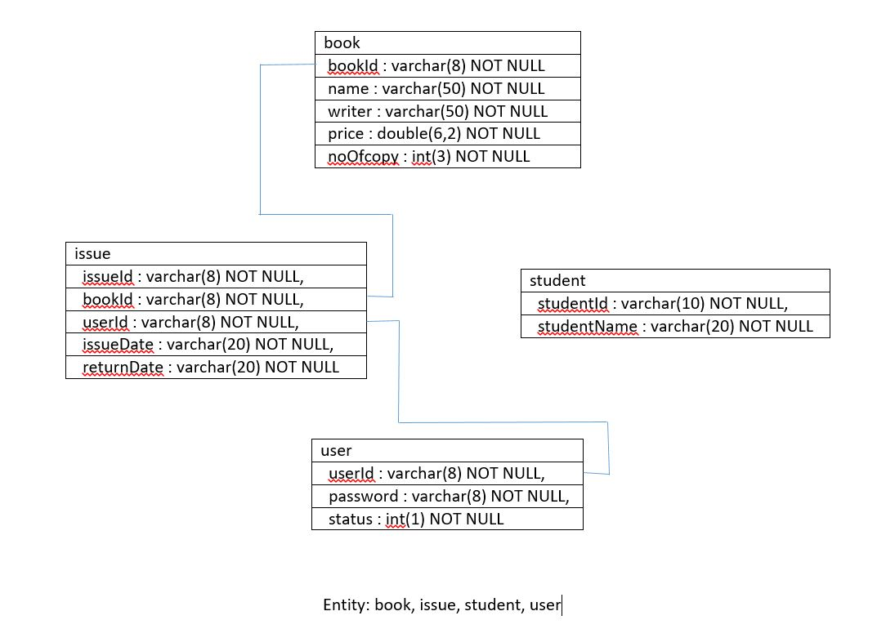

**Class Diagram:**

Draw a class diagram of your project here. You can draw then in a paper and add the image of the paper.

**Tools Used:**

To develop this project we have used the following:

* Notepad++
* Xammp
* Mysql
* JDBC driver

**OOP and Java Concepts Used:**

* **Inheritance-** In this concept the subclasses acquire the property of parent classes.
* **Method overriding-** It is a concept which allows a subclass to provide a specific implementation of a method
* **Polymorphism-** In this concept the parents class reference is used to refer a child class.
* **Abstraction** – In this concept the implementation details are kept hidden from the user.
* **Package-** It is a group of classes interfaces, entities etc.

There are also many concepts used in this project.

**Impact of this Project:**

This project will save a lot of time for the libraries. The interface will make the works easier and convenient. As we used database, this will be easier for the users to find any data within a short time and as well as storing data safely.

**Limitations and Possible Future Improvements:**

We made this project offline based. If there is online connectivity then we can add many more features. Besides this user interface would be easier to use. Many bugs could be easily fixed. More or less the project would be more easier and helpful.